Benchmarking Novel Sequence Models for ECG Arrhythmia Classification: KAN, S4, and Hybrid Architectures on MIT-BIH
Richard Konsam
North Eastern Regional Institute of Science and Technology
richardkonsam@gmail.com

Abstract—Cardiovascular disease accounts for approximately 17.9 million deaths annually, making automated arrhythmia detection from electrocardiogram (ECG) signals a critical clinical priority. While convolutional neural networks dominate the literature, novel architectures such as Kolmogorov-Arnold Networks (KAN) and State Space Models (SSM) remain unexplored on standard ECG benchmarks. This paper presents a systematic comparison of seven deep learning architectures on the MIT-BIH Arrhythmia subset of the Kaggle ECG Heartbeat Categorization Dataset (109,446 beats, 5 classes). Models evaluated include ResNet1D, TCN, BiGRU, a Transformer encoder, KAN, a hybrid ConvKAN, and S4ECG. To address severe class imbalance, WeightedRandomSampler and Focal Loss were applied during training. Results show that ResNet1D achieves the highest macro F1 score of 0.931 at 1.87M parameters, while KAN achieves a competitive 0.881 macro F1 with only 142k parameters, representing a 13-fold reduction in parameter count. Transformer and S4 architectures underperform on the 187-timestep fixed-length signals, suggesting their advantages are specific to longer sequences. KAN is identified as the most parameter-efficient model and a promising candidate for resource-constrained cardiac monitoring applications.
Index Terms—arrhythmia classification, ECG, Kolmogorov-Arnold Networks, state space models, MIT-BIH, deep learning, parameter efficiency.

I. INTRODUCTION
Cardiovascular disease remains the leading cause of mortality worldwide, responsible for an estimated 17.9 million deaths annually according to the World Health Organization [1]. The electrocardiogram (ECG) is the primary non-invasive diagnostic tool for detecting cardiac arrhythmias, yet manual interpretation of continuous ECG recordings is slow, subjective, and prone to inter-clinician variability. Automated classification systems that can reliably identify arrhythmia types from ECG signals are therefore of significant clinical and practical value.
Deep learning has driven substantial progress in automated ECG analysis. Convolutional neural networks (CNNs) have emerged as the dominant paradigm, accounting for approximately 58.7% of published deep learning approaches to ECG classification according to a recent systematic review [6]. Recurrent architectures such as LSTMs and GRUs have also been widely applied, and attention-based Transformers have seen growing adoption in recent years. These approaches have been benchmarked extensively on the MIT-BIH Arrhythmia Database [2], which remains the most widely used reference dataset for single-lead arrhythmia classification.
However, two families of architectures that have attracted significant theoretical interest have not been evaluated on the standard MIT-BIH benchmark. Kolmogorov-Arnold Networks (KAN), proposed by Liu et al. [4], replace fixed activation functions with learnable B-spline functions on network edges, offering a more expressive and interpretable alternative to conventional multilayer perceptrons. State Space Models (SSMs), particularly the Structured State Space (S4) architecture of Gu et al. [5] and its simplified variant S4D, are designed for efficient long-range sequence modelling using FFT-based convolution. Both families have demonstrated promise in time series and signal processing tasks, yet their suitability for short fixed-length biosignal classification remains untested.
This paper addresses this gap with the following contributions:
- We provide the first systematic benchmark of KAN and S4D on the Fazeli et al. MIT-BIH Kaggle benchmark dataset.
- We evaluate a novel hybrid ConvKAN architecture that combines multi-scale convolutional feature extraction with a KAN classifier head.
- We demonstrate that KAN achieves the best accuracy-per-parameter trade-off among all tested architectures, making it a compelling candidate for resource-constrained deployment.
- We provide a negative result for S4D, showing that SSMs do not generalise to short fixed-length ECG segments without architectural modification.

II. RELATED WORK

A. ECG Classification with Deep Learning
The Fazeli et al. dataset [1] established ResNet-based transfer learning as a strong baseline for single-lead ECG classification, achieving near-human performance on the MIT-BIH benchmark. Subsequent work has explored a variety of CNN, LSTM, and hybrid architectures on the same benchmark, with macro F1 scores for minority classes remaining the key challenge due to severe class imbalance. A 2023 systematic review by Xiao et al. [6] surveying 368 studies confirmed that CNNs account for the plurality of published approaches, with attention mechanisms and recurrent networks representing the two
next largest categories. Despite this volume of work, comparisons across architectures on a single controlled benchmark remain relatively rare.

B. Kolmogorov-Arnold Networks
Liu et al. [4] introduced KAN as a theoretically grounded alternative to MLPs, replacing fixed activation functions with learnable univariate functions parameterised as B-splines on network edges. This design increases representational flexibility and provides a path toward interpretability by allowing the learned edge functions to be visualised directly. Dong et al. [7] applied KAN to time series classification tasks and found competitive performance against CNN baselines at reduced parameter counts. A concurrent biomedical signals study on medRxiv reported promising KAN results for EEG and physiological signal classification. To our knowledge, no published work has evaluated KAN on the standard MIT-BIH ECG Heartbeat Categorization benchmark.

C. State Space Models
The S4 architecture [5] and its simplified diagonal variant S4D addressed the challenge of modelling long-range dependencies in sequences of thousands of timesteps, using structured state transition matrices and FFT-based convolution for linear-complexity inference. Subsequent work has applied SSMs to medical time series: ECGMamba (2024) applied a Mamba-based SSM to 12-lead ECG classification and reported state-of-the-art results on the PTB-XL dataset. However, ECGMamba operates on substantially longer sequences from 12-lead recordings, and has not been evaluated on the single-lead 187-timestep MIT-BIH benchmark used here. The behaviour of S4D on short fixed-length biosignal segments therefore remains an open question.

III. DATASET
The dataset used in all experiments is the MIT-BIH portion of the Kaggle ECG Heartbeat Categorization Dataset, curated by Fazeli et al. [1] from the PhysioNet MIT-BIH Arrhythmia Database [2,3]. It consists of 109,446 pre-segmented single-beat ECG recordings, each represented as a fixed-length sequence of 187 timesteps sampled at 125 Hz and normalised to the range [0,1]. Beats are labelled according to the AAMI EC57 standard into five classes: N (normal), S (supraventricular ectopic), V (ventricular ectopic), F (fusion), and Q (unknown/paced).
The dataset exhibits severe class imbalance. The class distribution is shown in Table I. Class N comprises approximately 66% of all beats, while the minority class F contains only 641 samples, a ratio of approximately 113:1. This imbalance is the central methodological challenge of the dataset and has a direct bearing on macro-averaged F1 scores, which weight all classes equally regardless of sample count.
TABLE I
MIT-BIH Class Distribution

Class | Label | Description | Count | Percentage
0 | N | Normal beat | 72,471 | 66.2%
1 | S | Supraventricular ectopic | 5,788 | 5.3%
2 | V | Ventricular ectopic | 6,431 | 5.9%
3 | F | Fusion beat | 641 | 0.6%
4 | Q | Unknown / Paced | 2,223 | 2.0%
 |  | Total | 109,446 | 100%
An 80/20 stratified train-test split was used, preserving class proportions in both partitions. All experiments used a fixed random seed of 42 for reproducibility.

IV. METHODOLOGY

A. Preprocessing and Imbalance Handling
The signals were already segmented and normalised to [0,1] by Fazeli et al., requiring no additional preprocessing. Two complementary strategies were applied to address class imbalance during training. First, a WeightedRandomSampler was used to oversample minority classes during batch construction, with each class sampled proportional to the inverse of its frequency. Second, Focal Loss with a focusing parameter γ = 2.0 was used as the training objective in place of standard cross-entropy. Focal Loss progressively down-weights easy majority-class examples during training, concentrating gradient updates on the harder minority-class samples.

B. Model Architectures
Seven architectures were evaluated, spanning established baselines and novel approaches:
ResNet1D (1.87M parameters): A one-dimensional residual network following the architecture of Fazeli et al. [1], consisting of five residual blocks with 1D convolutions, batch normalisation, and skip connections. This serves as the primary performance baseline.
TCN (137k parameters): A Temporal Convolutional Network [8] using dilated causal convolutions with an exponentially increasing dilation schedule, enabling a large receptive field with few parameters.
BiGRU (400k parameters): A bidirectional Gated Recurrent Unit network that processes the ECG sequence in both temporal directions, capturing both past and future context at each timestep.
TransformerECG (151k parameters): A patch-based Transformer encoder that divides the 187-timestep signal into non-overlapping patches and applies multi-head self-attention across patch representations.
KAN (142k parameters): A Kolmogorov-Arnold Network [4] applied directly to the ECG signal. Each connection in the network carries a learnable B-spline activation function, rather than a fixed nonlinearity. This enables per-connection function learning without requiring convolutional or recurrent inductive bias.
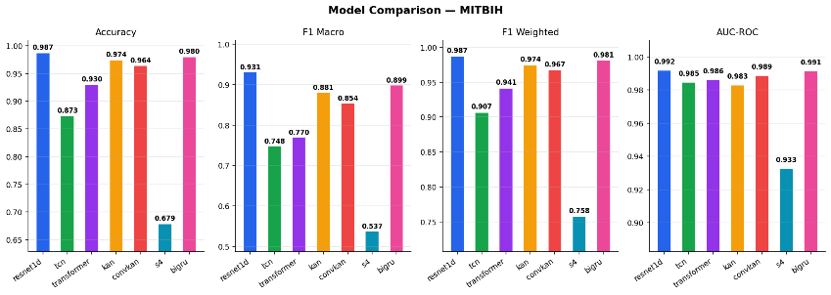
ConvKAN (151k parameters): A hybrid architecture combining multi-scale 1D convolutional feature extraction with a KAN classifier head. The convolutional frontend extracts local morphological features at multiple temporal scales, which are then passed to the KAN for classification.
S4ECG (19k parameters): A State Space Model using the S4D diagonal parameterisation [5], with FFT-based convolution for efficient sequence processing. This is the most parameter-efficient model in the comparison.

C. Training Protocol

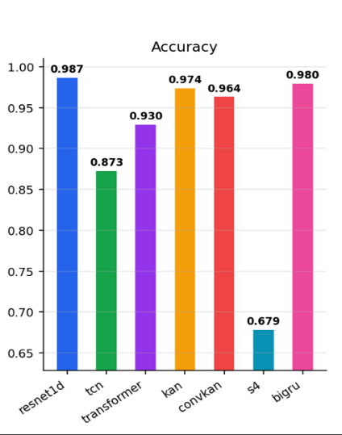
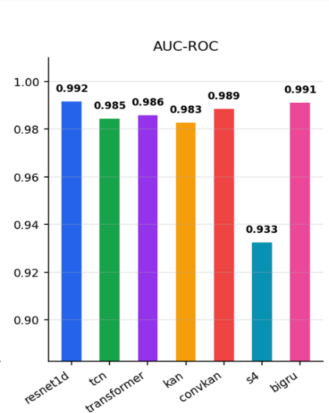
All models were trained under a unified protocol to ensure fair comparison. The AdamW optimiser was used with a learning rate of 1×10⁻³ and weight decay of 1×10⁻⁴. A cosine annealing learning rate schedule was applied over 30 epochs, decaying from the initial rate to a minimum of 1% of the initial value. Automatic Mixed Precision (AMP, fp16) was enabled to reduce memory consumption and training time. Gradient clipping with a maximum norm of 1.0 was applied to prevent exploding gradients. All experiments used batch size 256, an 80/20 train-test split, and a fixed random seed of 42. Training was performed on an NVIDIA RTX 3050Ti Laptop GPU (4GB VRAM) with CUDA 12.4.

V. RESULTS AND DISCUSSION

A. Overall Performance
Table II summarises the performance of all seven models on the MIT-BIH test set. ResNet1D achieves the highest performance across all metrics, with a macro F1 score of 0.931, weighted F1 of 0.987, and AUC-ROC of 0.992. BiGRU ranks second overall with a macro F1 of 0.899. KAN achieves a macro F1 of 0.881 despite having 13 times fewer parameters than ResNet1D, representing the best parameter-efficiency trade-off in the comparison. Figure 1 provides a visual overview of per-metric comparisons across all models.

TABLE II
Performance Comparison on MIT-BIH Test Set
Model | Params | Accuracy | F1 Macro | F1 Weighted | AUC-ROC
ResNet1D | 1.87M | 0.987 | 0.931 | 0.987 | 0.992
BiGRU | 400k | 0.980 | 0.899 | 0.981 | 0.991
KAN | 142k | 0.974 | 0.881 | 0.974 | 0.983
ConvKAN | 151k | 0.964 | 0.854 | 0.967 | 0.989
Transformer | 151k | 0.930 | 0.770 | 0.941 | 0.986
TCN | 137k | 0.873 | 0.748 | 0.907 | 0.985
S4ECG | 19k | 0.679 | 0.537 | 0.758 | 0.933

Fig. 1. Model Comparison across four evaluation metrics on the MIT-BIH test set. ResNet1D leads overall; KAN achieves competitive macro F1 with significantly fewer parameters.

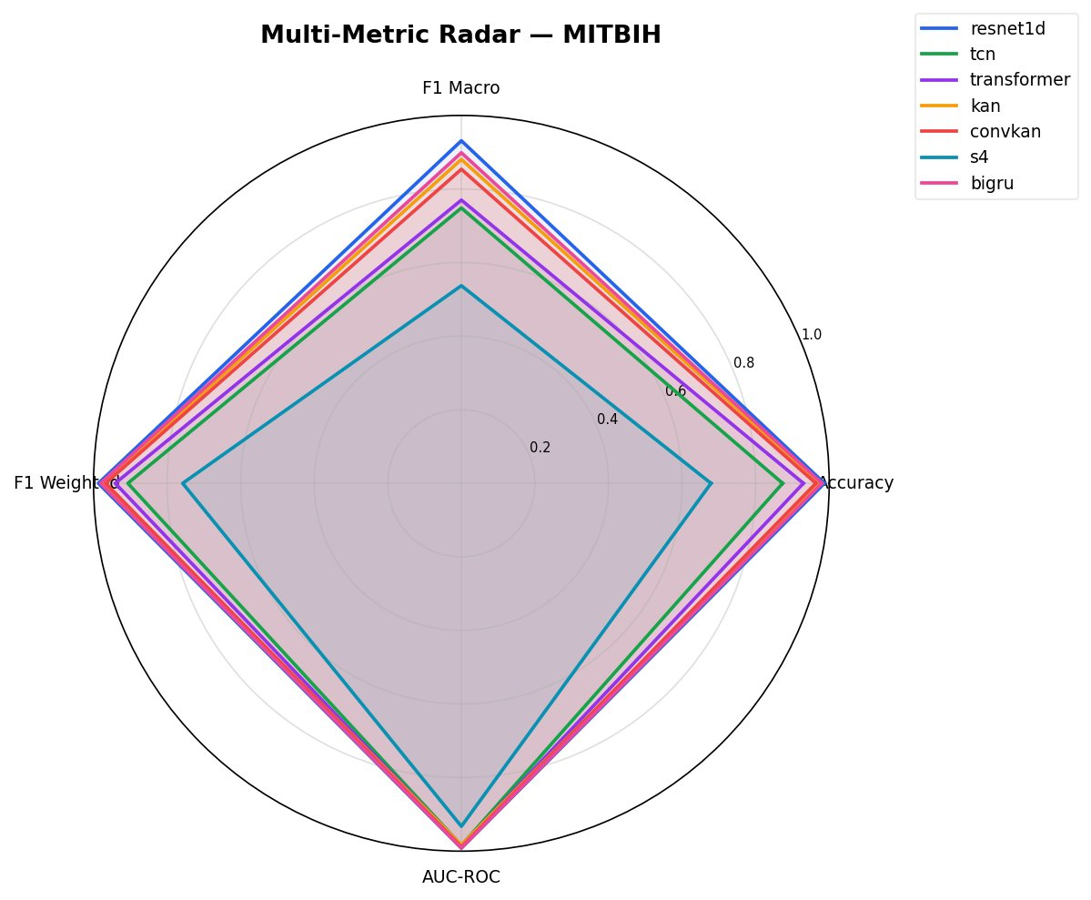
B. Parameter Efficiency
Figure 2 plots macro F1 score against parameter count for all models. This is the key result of the paper. KAN occupies the most favourable position in the upper-left region of the plot, combining a high macro F1 of 0.881 with only 142k parameters. This positions KAN as the optimal choice when computational resources or memory are constrained, such as in wearable ECG devices or embedded cardiac monitors.
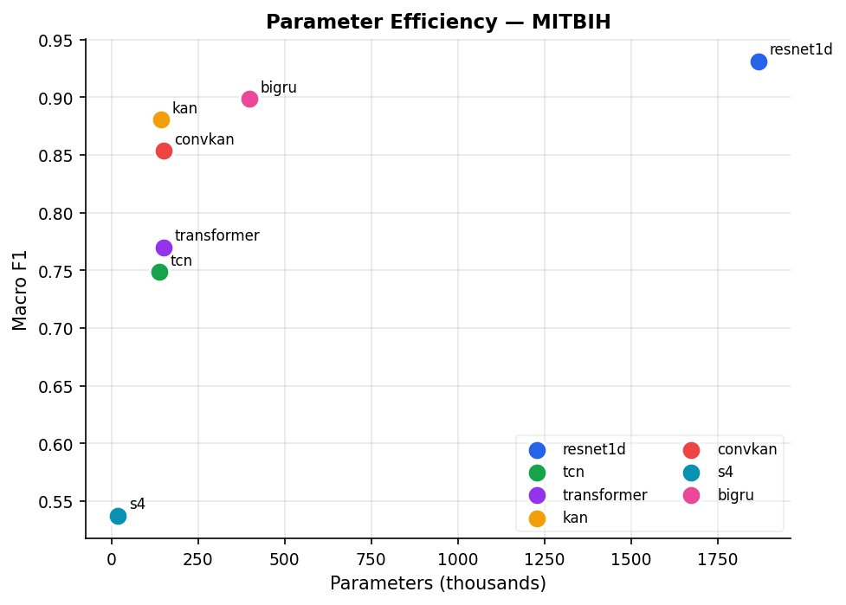
BiGRU achieves a higher absolute macro F1 (0.899) but requires nearly three times as many parameters (400k). ResNet1D, while achieving the highest performance (0.931), uses 1.87M parameters, over 13 times more than KAN. S4ECG, despite having the fewest parameters (19k), achieves by far the lowest macro F1 (0.537), demonstrating that parameter count alone does not determine efficiency.

Fig. 2. Parameter efficiency plot. Each point represents one model; the upper-left region indicates high performance at low parameter cost. KAN achieves the best accuracy-per-parameter trade-off.

C. Multi-Metric Overview
Figure 3 presents a radar chart spanning four metrics: accuracy, macro F1, weighted F1, and AUC-ROC. The chart visually confirms that ResNet1D and BiGRU form a clear top tier, with KAN and ConvKAN forming a competitive second tier. Transformer and TCN occupy the third tier, and S4ECG is a clear outlier. Notably, the gap between models is most pronounced on the macro F1 axis, reflecting differences in performance on minority classes, while AUC-ROC scores are considerably more compressed, with all models except S4ECG scoring above 0.980.

Fig. 3. Multi-metric radar chart comparing all seven models across accuracy, macro F1, weighted F1, and AUC-ROC on the MIT-BIH test set.

D. KAN vs. ConvKAN
Plain KAN (macro F1 = 0.881) outperforms ConvKAN (macro F1 = 0.854) despite ConvKAN incorporating additional convolutional preprocessing layers. This is a somewhat counterintuitive result. One interpretation is that the learnable B-spline activations within KAN are already sufficiently expressive to capture the local morphological features of the 187-point ECG segment without requiring explicit convolutional inductive bias. In other words, the function approximation capacity of the KAN layers subsumes the feature extraction role that convolutions would otherwise provide. An alternative explanation is that the convolutional frontend introduces an information bottleneck or training instability that reduces the capacity of the subsequent KAN to learn discriminative features. Further ablation studies would be needed to distinguish these hypotheses.

E. Transformer Underperformance
The patch-based Transformer achieves a macro F1 of 0.770, below KAN, BiGRU, and even the simpler TCN. This is consistent with findings in the broader sequence modelling literature, where attention mechanisms are known to provide diminishing returns on short sequences. At 187 timesteps, divided into a small number of patches, the self-attention mechanism's quadratic computational complexity provides no compensating benefit over architectures with stronger local inductive biases. These results suggest that vanilla Transformer architectures are not well-suited to this class of short fixed-length biosignal classification tasks without significant architectural adaptation.
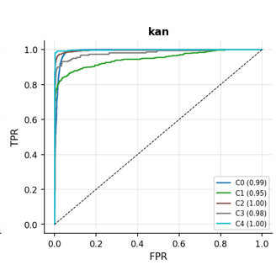
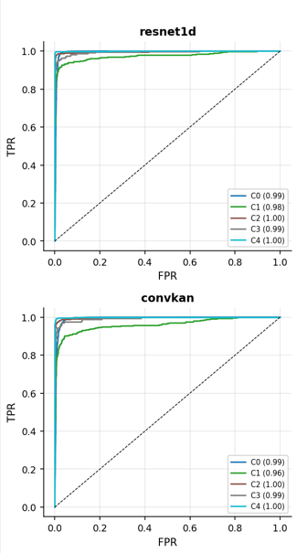

F. S4ECG Negative Result
S4ECG achieves the lowest performance across all metrics, with a macro F1 of 0.537 and accuracy of 0.679. This constitutes a clear negative result. The S4D architecture's theoretical advantage lies in efficient modelling of very long sequences (thousands of timesteps), where its FFT-based convolution kernel can capture long-range dependencies that are inaccessible to finite-context CNNs and RNNs. At 187 timesteps, this advantage is absent: the sequence is short enough for standard convolutional architectures to capture full temporal context within a small number of layers. Furthermore, the FFT-based convolution kernels appear to converge less reliably than learned CNN filters on this task within the 30-epoch training budget. This negative result is informative: SSMs should not be treated as drop-in replacements for CNNs on short fixed-length biosignal segments.

G. Per-Class Analysis
Figure 4 shows the per-class ROC curves for all models. All models achieve near-perfect discrimination for class C2 (ventricular ectopic, AUC ≥0.99 for the top models) and class C4 (paced/unknown). The most challenging class across all models is C1 (supraventricular ectopic, S), which suffers from both morphological similarity to normal beats and severe underrepresentation in the training data. S4ECG shows substantially degraded AUC on C1 (0.83) compared to the other models (0.95–0.98).
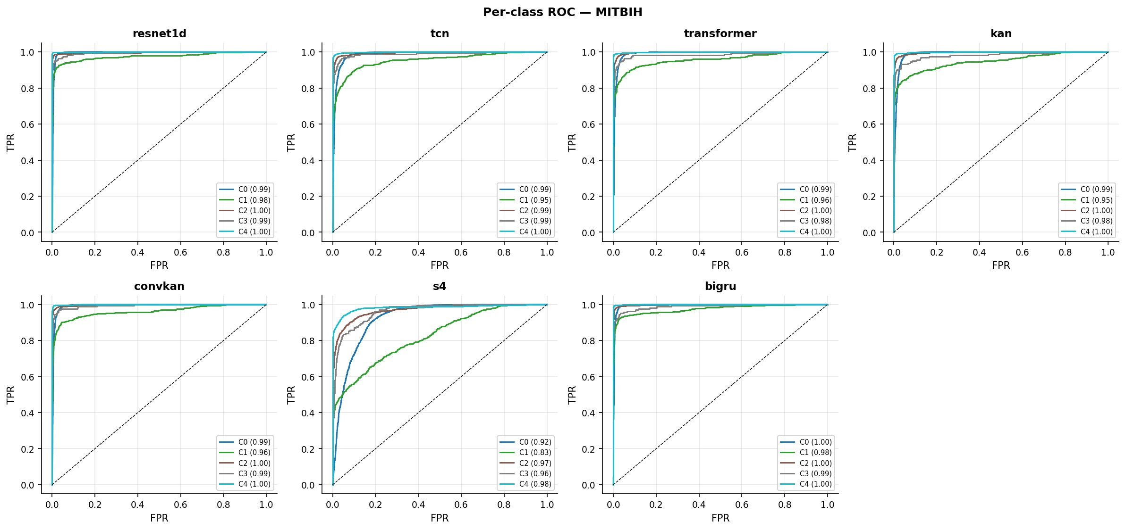
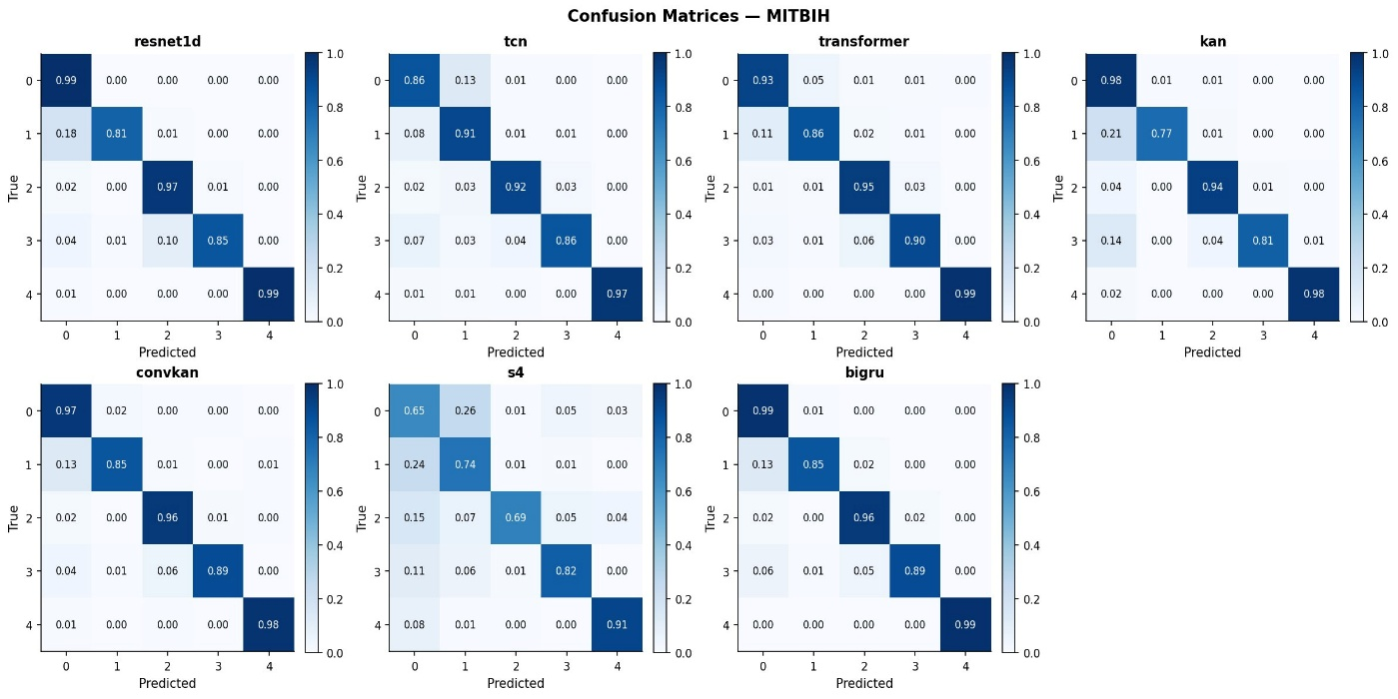
Fig. 4. Per-class ROC curves for all seven models on the MIT-BIH test set. C1 (supraventricular ectopic) is the most challenging class across all architectures.
Figure 5 shows the normalised confusion matrices for all models. Consistent with the ROC analysis, the S row (class 1) shows the highest misclassification rates across all models, predominantly as class N (normal). ResNet1D achieves 81% recall on class S; TCN achieves the highest class-1 recall at 91%, an architecturally interesting result given its lower overall macro F1, suggesting TCN may have a structural advantage in detecting supraventricular beats. S4ECG shows widespread confusion across all classes, confirming its overall underperformance.
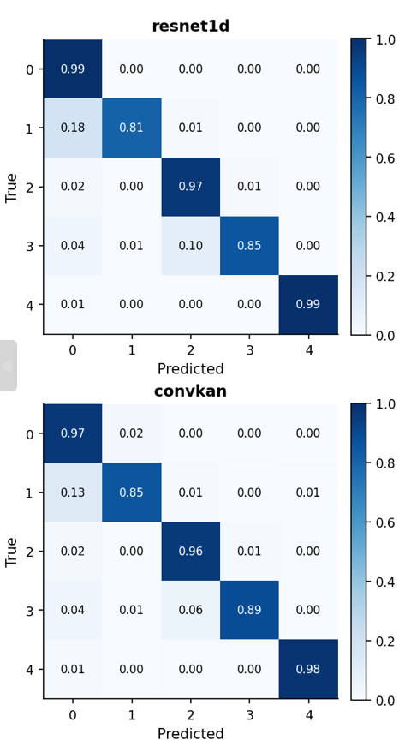
Fig. 5. Normalised confusion matrices for all seven models. Class 1 (S, supraventricular ectopic) shows the highest misclassification rate across all architectures due to morphological similarity with normal beats.

VI. CONCLUSION
This paper presented the first systematic benchmark of Kolmogorov-Arnold Networks and S4D State Space Models on the MIT-BIH Arrhythmia ECG benchmark. Seven architectures were evaluated under a unified training protocol with explicit handling of class imbalance via WeightedRandomSampler and Focal Loss.
The primary finding is that KAN achieves a macro F1 score of 0.881 with only 142k parameters, representing the best accuracy-per-parameter trade-off of all models tested. This positions KAN as a compelling candidate for deployment in resource-constrained cardiac monitoring applications such as wearable ECG devices and edge processors. The hybrid ConvKAN did not improve upon plain KAN, suggesting that KAN's learnable activation functions are sufficient for feature extraction from short fixed-length ECG segments.
Transformer and S4ECG architectures underperformed on this task. The Transformer's self-attention mechanism provides no advantage over CNNs at 187 timesteps, and the S4D model's FFT-based convolution did not converge reliably on short segments. These are useful negative results for the community: not all sequence modelling innovations transfer directly to short fixed-length biosignal classification.
Future work should investigate: (1) evaluation of KAN on raw PhysioNet signals without fixed-length segmentation; (2) application of KAN to multi-lead ECG datasets such as PTB-XL; (3) self-supervised pretraining of KAN encoders to leverage unlabelled ECG data; and (4) interpretability analysis of KAN's learned spline activations per arrhythmia class, which may reveal clinically meaningful morphological features.

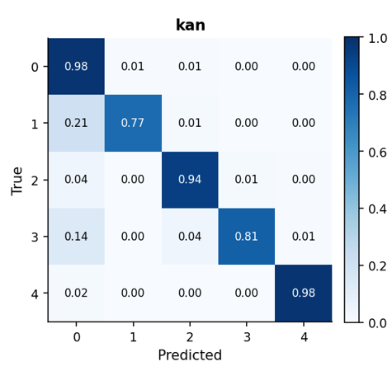
REFERENCES
[1] N. Fazeli et al., "ECG Heartbeat Classification: A Deep Transferable Representation," arXiv:1805.00794, 2018.
[2] G. B. Moody and R. G. Mark, "The impact of the MIT-BIH Arrhythmia Database," IEEE Engineering in Medicine and Biology, vol. 20, no. 3, pp. 45–50, 2001.
[3] A. L. Goldberger et al., "PhysioBank, PhysioToolkit, and PhysioNet: Components of a New Research Resource for Complex Physiologic Signals," Circulation, vol. 101, no. 23, 2000.
[4] Z. Liu et al., "KAN: Kolmogorov-Arnold Networks," arXiv:2404.19756, 2024.
[5] A. Gu et al., "Efficiently Modeling Long Sequences with Structured State Spaces," arXiv:2111.00396, 2021.
[6] Z. Xiao et al., "Deep Learning-Based ECG Arrhythmia Classification: A Systematic Review," Applied Sciences, vol. 13, no. 8, 2023.
[7] Y. Dong et al., "KAN for Time Series Classification and Robust Analysis," arXiv:2408.07314, 2024.
[8] S. Bai, J. Z. Kolter, and V. Koltun, "An Empirical Evaluation of Generic Convolutional and Recurrent Networks for Sequence Modeling," arXiv:1803.01271, 2018.
[9] World Health Organization, "Cardiovascular Diseases (CVDs)," WHO Fact Sheet, 2023.

